|  |  |
| --- | --- |
| **Name** | **Umar Hayyat** |
| **Roll No** | **2019-EE-360** |

**Lab report 1**

**Introduction to Java programming**

**Objectives:**

In this lab,

* I will learnt how we install the Netbean and create environment.
* I will learnt how we write code in java language.

**Task #1:**

**How we can install Net Beans IDE 8.0.2** **and jdk?**

**Procedure:** First of all, I installed Java SE Runtime Environment (jdk-8u231-windows-i586.exe) in my computer.

Then, I installed Net Beans IDE 8.0.2 in my Computer.

**Task #2:**

**How to create new Java project?**

**Procedure:** Click on ‘File’ from Net Beans menu bar and select New Project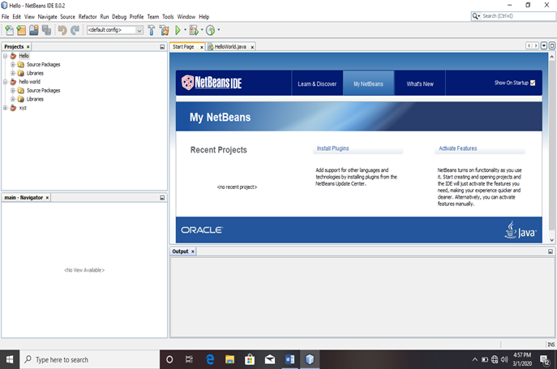

New project will be open and now select ‘java’ from categories and select ‘java Application ‘from projects and then ‘Next’.

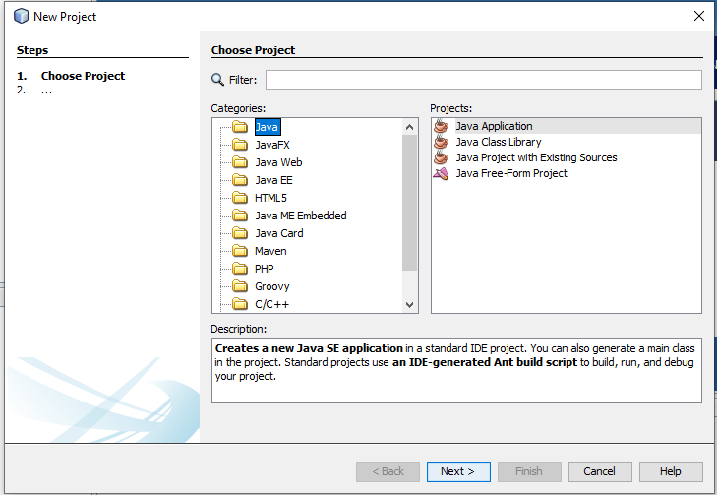

We have an option to give name and location to our project. After that click on ‘finish’ button and our project will be create.

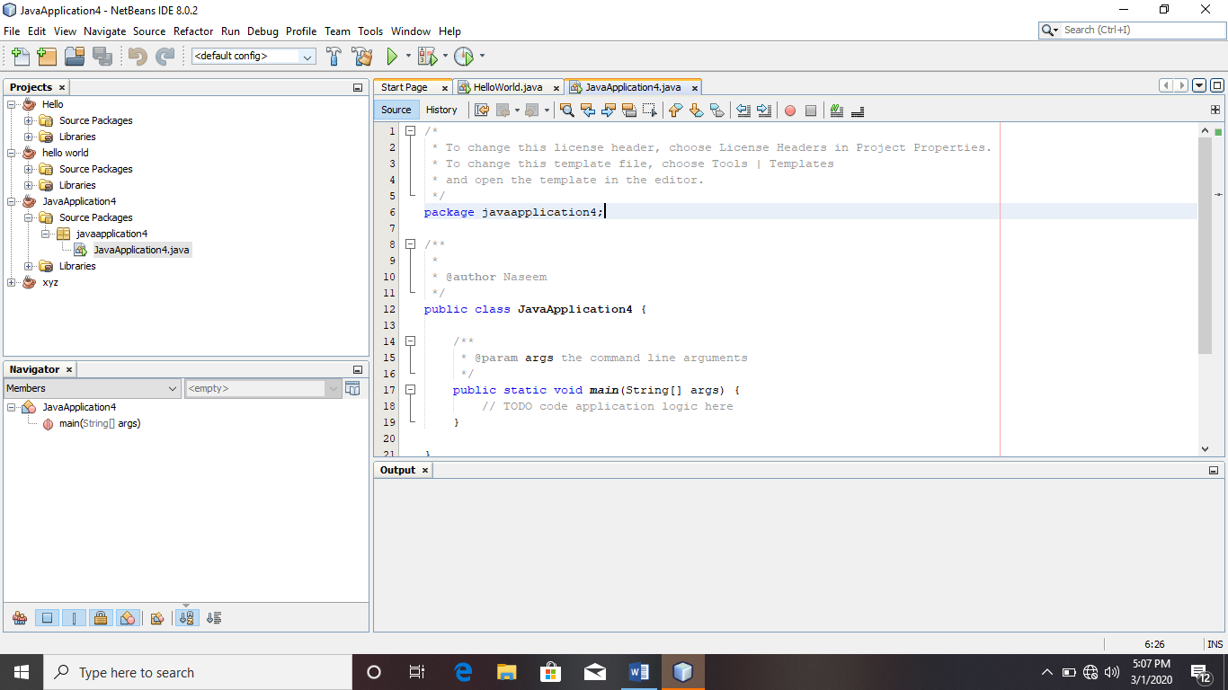

Note: The name of the ‘project’ and ‘public class name’ in the program should be same.

**Task #3:**

**Write a java program that displays ‘Hello World’, ‘Hello UET’ and your Name on output.**

**Code:**

public class NewClass1 {

public static void main(String[] args) {

/*

*print different characters

*name etc.

*/

System.out.println("Hello World");

System.out.println("Hello UET");

System.out.println("Umar Hayyat,2019EE360");

}

}

**Output:**

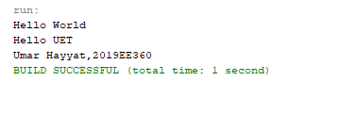

**Conclusion:**

In this lab:

I learnt how to write a code in java language after creating environment. I learnt how it is different from other language. I learnt the difference between print and println. I also learnt how we use println to print any statement. I learnt how it is different to print any code or statement in java from other languages.